**VI EDITOR**

**VI (VISUAL INSTRUMENT):**

Creating Files:

* Creating File by using vi command.



Vi Editors has three modes:

* Command mode
* Insert mode
* Execution mode

**COMMAND MODE:**

Single line copy and paste:

* yy 🡪 to copy a line in command mode.
* p 🡪 to paste a line in command mode.



Multiple line copy and paste:

* 4yy 🡪 to copy 4 lines in command mode.
* 2p 🡪 to paste 2 times in command mode.

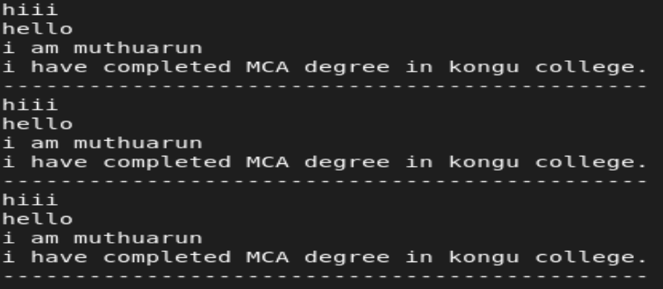

Delete a Single line and Multiple lines:

* dd 🡪 to delete a line in command mode.
* 4dd 🡪 to delete 4 lines in command mode.

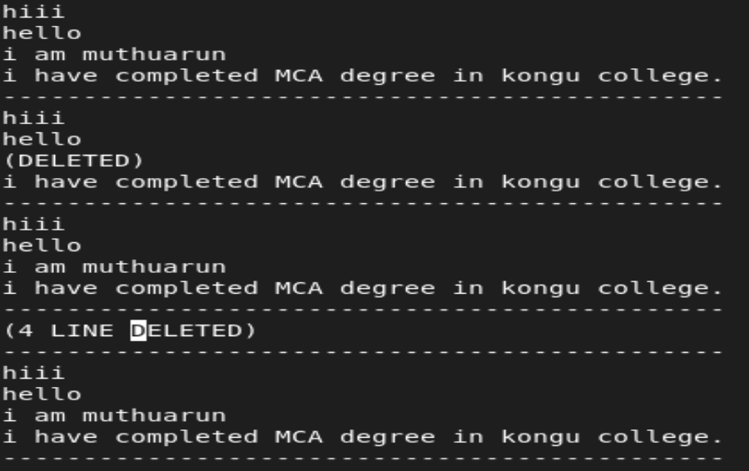

Move the cursor beginning and ending of files:

* gg 🡪 moves the cursor to the Beginning of file.
* Shift + g 🡪 moves the cursor to the Ending of file.

Search a Key Word in Command Mode:

* /[word] (or) ?[word] 🡪 To search any key word in file.

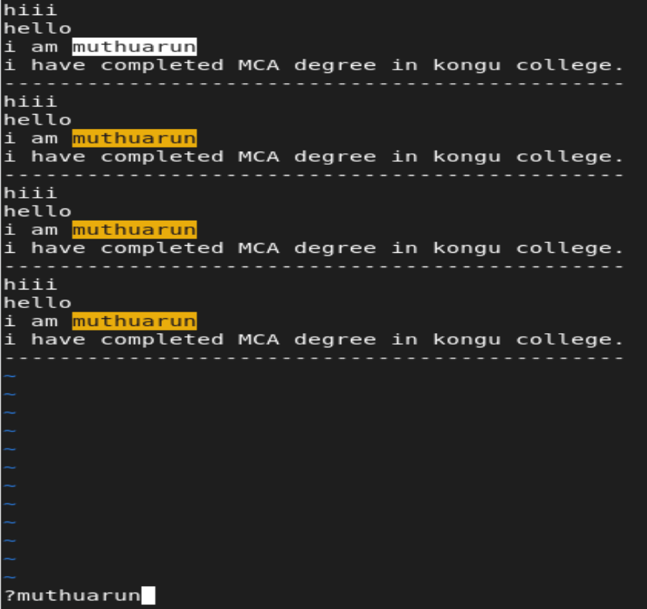

* u 🡪 undo
* ctrl + r 🡪 redo

**To move cursor in command mode:**

* h - move to left
* j - move to down
* k - move to top
* l - move to right

**INSERT MODE:**

* i 🡪 insert the text
* I 🡪 insert the text in beginning of line
* a 🡪 adds the text after the current cursor position
* A 🡪 adds the text at the end of a line
* 🡪 inserts the text one line below current cursor position
* 🡪 inserts the text one line before current cursor position

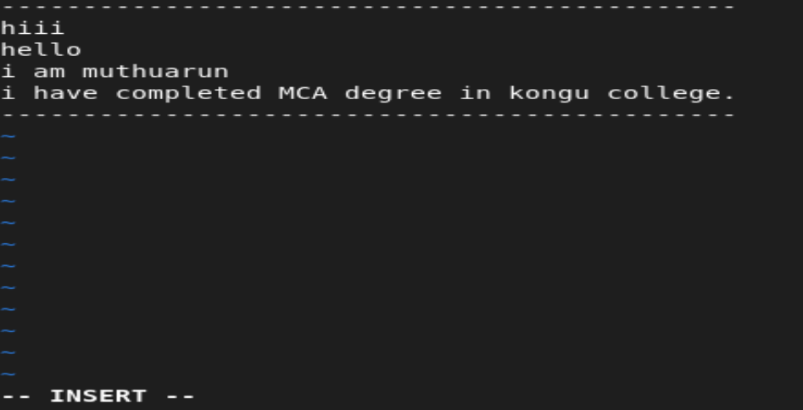

**EXECUTION MODE:**

* :q 🡪 without saving quite from file
* :q! 🡪 forcefully quite

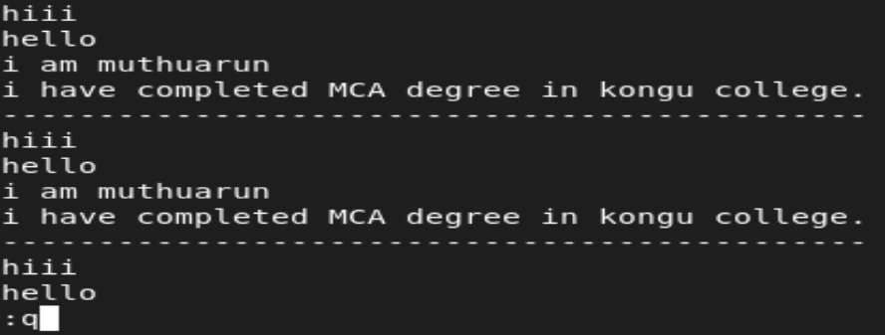 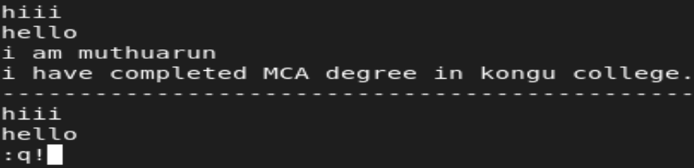

* :w 🡪 save the changes
* :w! 🡪 forcefully save changes

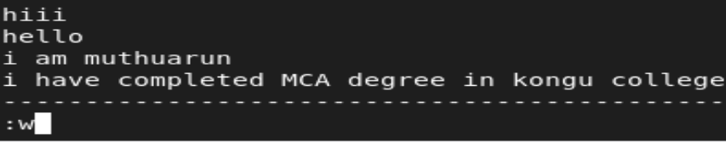 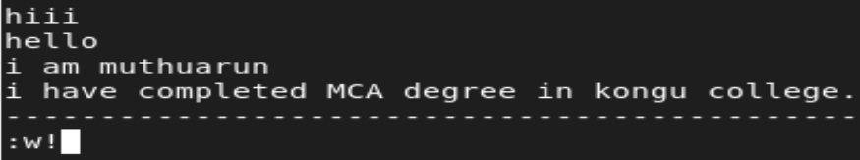

* :wq 🡪 save and quite
* :wq! 🡪 forcefully save and quite

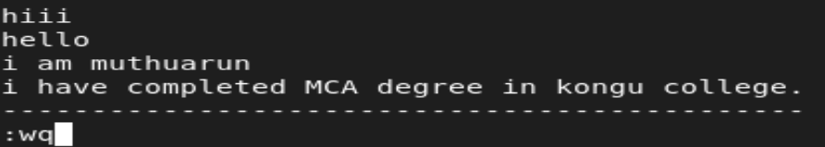 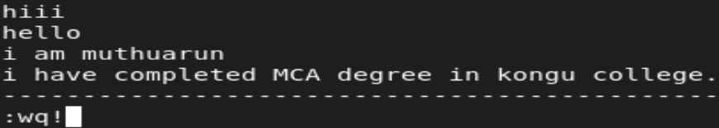

* :x 🡪 save and quite

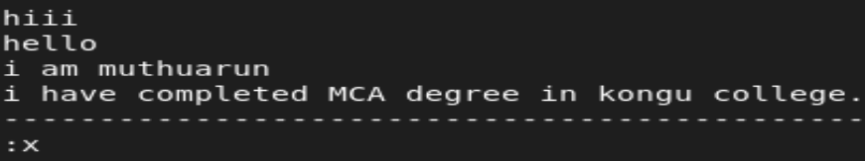

* :set nu 🡪 to set line numbers to line in the file
* :set nonu 🡪 remove line numbers

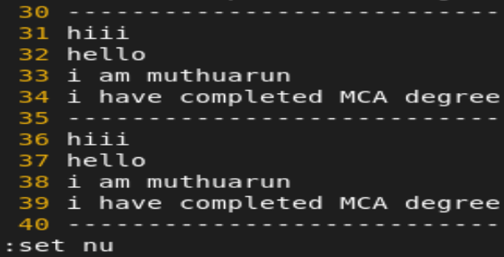 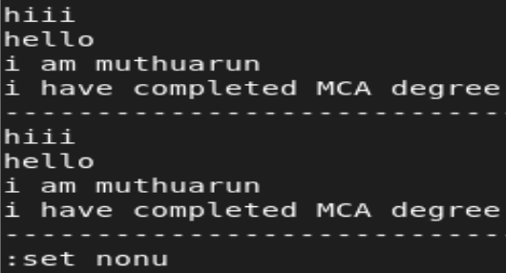

* :5d 🡪 delete 5th line

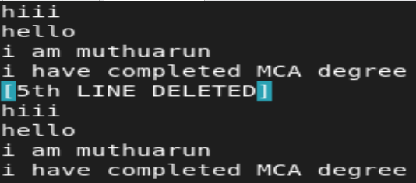

* :3,6d 🡪 delete 3rd line to 6th line

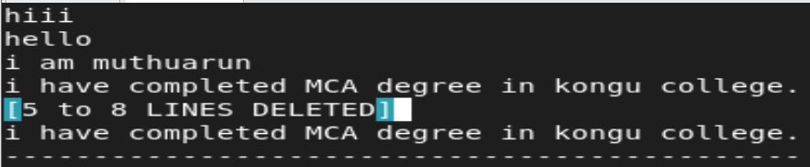

* :%s/Muthuarun(old name)/arun(new name)/g 🡪 TO search a word and replace in files.

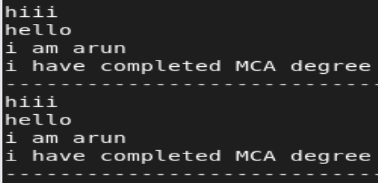

Without opening a file and find and replace a word:

* Sed -e s/oldname/newname/g muthuarun[filename]

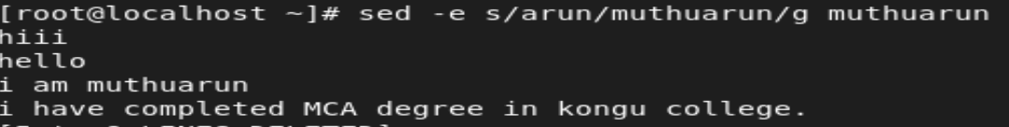

**GREP 🡪 Search a word from outside of the vi command:**

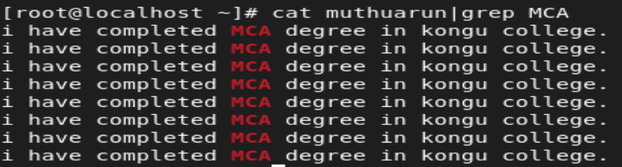

**HEAD :(Display top 10 lines in the file)**

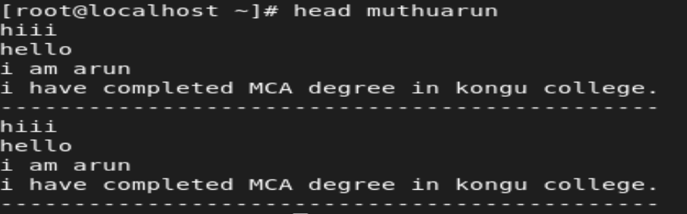

**TAIL :( Display bottom 10 lines in the file)**

